 **NIMS COLLEGE**

Registration No: 6-2-756-8-2019

(Tribhuvan University)

*Kanibahal, Lalitpur*

Lab Report

of

Software Project Management

Submitted by Submitted To

Raj Kumar Karki Department of Humanities & Social Science

Semester: 7th  BCA (Bachelor in Computer Application)

….………………………

External Examiner

# Table of Contents

|  |  |  |
| --- | --- | --- |
| **S.N** | **Topic** | **Signature** |
| 1. | Gantt Charts |  |
| 2. | Work Break Down Structure |  |
| 3. | Project Network Diagram |  |
| 4. | Kanban Boards |  |
| 5. | Risk Matrix |  |
| 6. | Time Sheets |  |
| 7. | Project Dashboards |  |
| 8. | Critical Path Method (CPM) |  |
| 9. | Earned Value Management (EVM) |  |
| 10. | Project Pipeline Management |  |

# Gantt Charts

**Definition:**

A Gantt Chart is a popular tool used in project management to visualize project schedules and timelines. It displays the project schedule in a graphical format that shows the start and end dates of each task, as well as the dependencies between tasks. (GANTT) stands for Generalized Activity Normalization Time Table.

**Tools:**

MatchWare MindView 9

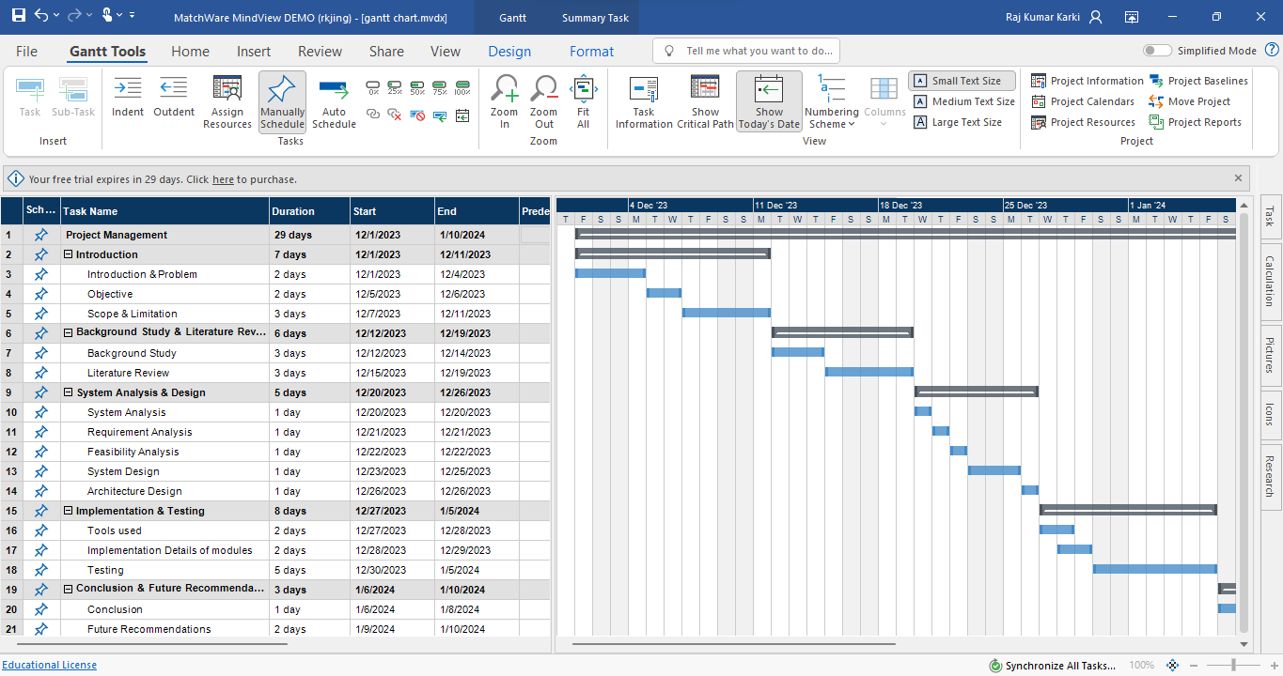

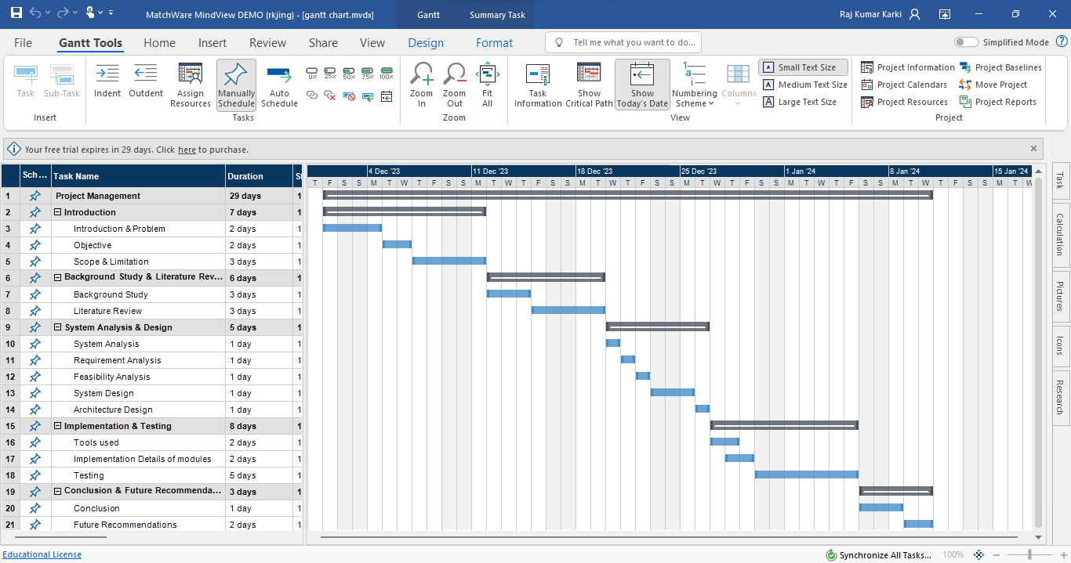

Figure: Gantt Chart

**Importance:**

Gantt Chart is a timetable that depicts how the project will progress during the Project Management Process. The importance of Gantt Chart is given below:

* To improve clarity, identify all relevant tasks, think through a project plan, and better define the scope of a project.
* Determine when tasks must be done and who the predecessors and dependencies are.
* Keep your team up to date on progress and changes, and reduce the need for frequent status reports and meetings.
* Discover the critical route of a project to determine the most vital tasks that must be completed on time.
* Simplify complicated jobs by breaking them down into smaller, more digestible chunks on a visual timeline.
* Keep track of and compare planned and actual timelines, and make sure that the latter is realistic and achievable.
* Allocate resources across a project's various concurrent tasks, and assign the right people to the correct jobs.
* Assist stakeholders and team members in collaborating.
* Reduce the time it takes to set up, maintain, and communicate in both large and small initiatives.
* Identify duties that are past due and take proactive actions to avoid problems.

**Conclusion:**

In Conclusion, using MatchWare software tools helped to create Gantt chart for project management, task scheduling, and progress tracking which visually represents tasks along a timeline, showing start and end dates of my project.

**Work Break Down Structure**

**Definition:**

Work Breakdown Structure (WBS) is a visual, hierarchical decomposition of a project into smaller, more manageable tasks. It is a deliverable-oriented breakdown of the project into smaller and more manageable components. The WBS helps project managers to identify all the tasks and deliverable required to complete a project, and to estimate the time and resources needed for each task.

**Tools:**

Creately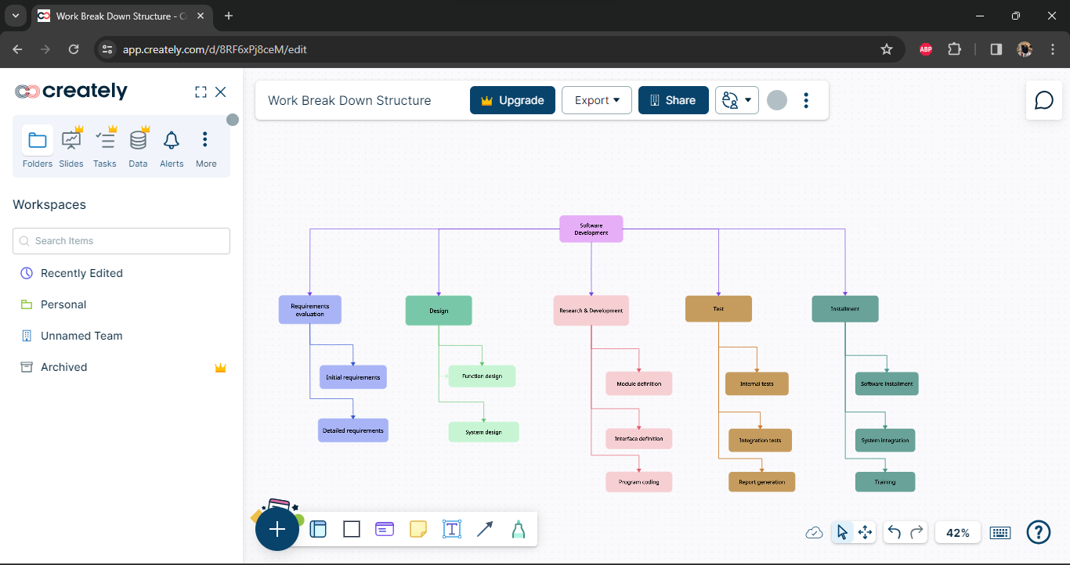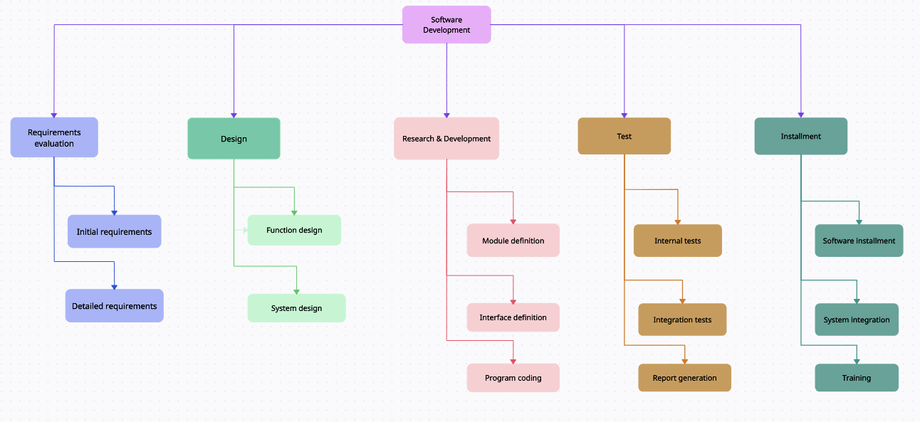

Figure: Work Break Down Structure

**Importance:**

The benefits of creating a WBS include:

* it defines and organizes the work required
* it facilitates the quick development of a schedule by allocating effort estimates to specific sections of the WBS
* it can be used to identify potential scope risks if it has a branch that is not well defined
* it provides a visual of entire scope
* it can be used to identify communication points
* it provides a visual of impacts when deliverables are falling behind
* it can be used to show and assign accountabilities and responsibilities
* it can show control points and milestones
* it provides a way to estimates project costs
* it ensures no important deliverables are forgotten
* it can assist with resource allocation
* it provides a proven and repeatable approach to planning projects
* it provides a tool for team brainstorming and collaboration
* it provides an opportunity to engage the team and make them feel invested in the planning

**Conclusion:**

In Conclusion, using Creatly software tool which help me to create WBS by organizing complex of my projects. WBS helped me to identifies essential deliverables, breaks down larger tasks into smaller components, and provides a clear task decomposition for assigning responsibilities.

**Project Network Diagram**

**Definition:**

A project network diagram visualizes the sequential and logical relationship between tasks in a project setting. This visualization relies on the clear expression of the chronology of tasks and events. This network diagram tool is used to map out the schedule and work sequence for the project, as well as track its progress through each stage up to and including completion.

**Tools:**

Wondershare EdrawMax

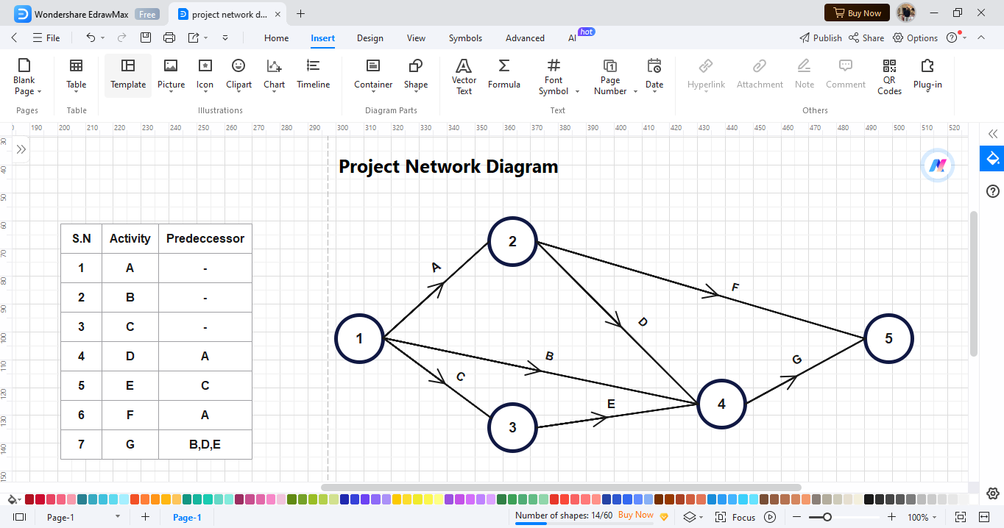

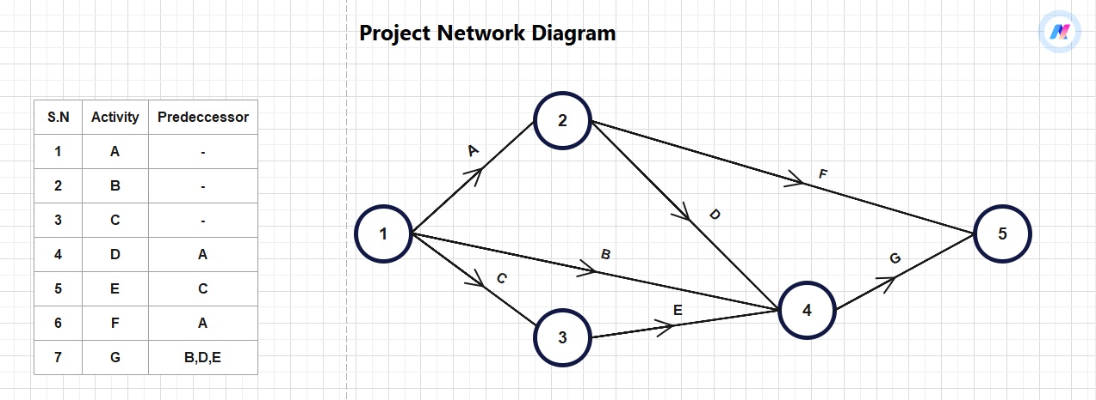

Figure: Project Network Diagram

**Importance:**

The importance of Project Network Diagrams in software project management:

1. **Visual Roadmap:** Network diagrams provide a visual representation of project tasks, their relationships, and flow.
2. **Critical Paths:** They highlight critical paths, aiding timely project completion.
3. **Resource Optimization:** By mapping task relationships, they help optimize resource allocation.
4. **Effective Communication:** Project network diagrams facilitate communication and coordination among team members and stakeholders.

**Conclusion:**

In Conclusion, using EdrawMax software tool which help to develop a Project Network Diagram serves as a visual compass, guiding teams through the intricate web of project tasks and dependencies. By mapping out activities, durations, and logical relationships, it unveils critical paths and potential bottlenecks. These diagrams empower project managers to optimize resource allocation, anticipate challenges, and ensure successful project execution

**Kanban Boards**

**Definition:**

Kanban is a workflow management method that allows project managers to visualize their team’s work on easy-to-use boards that facilitate the process of planning, [scheduling](https://www.projectmanager.com/guides/project-scheduling) and tracking work. The kanban methodology consists of kanban boards, kanban cards, principles and practices and is typically used to manage manufacturing and software development projects.

**Tools:**

MatchWare MindView 9

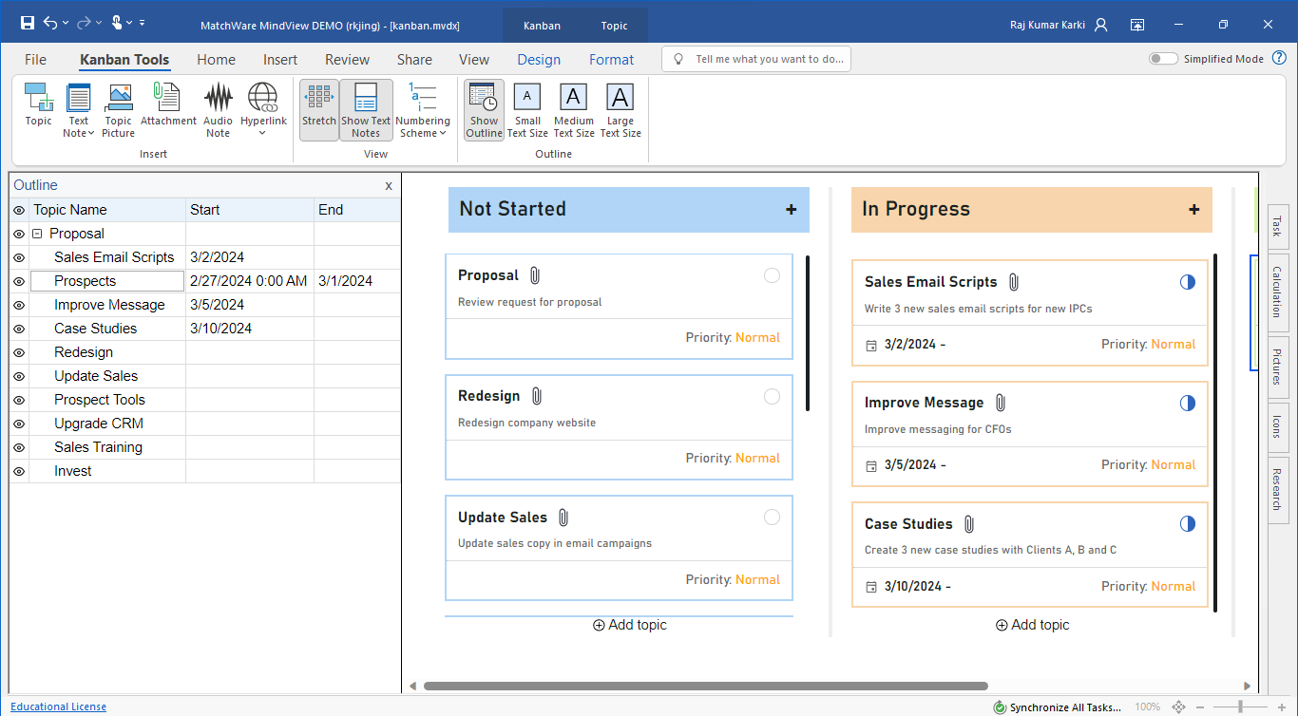

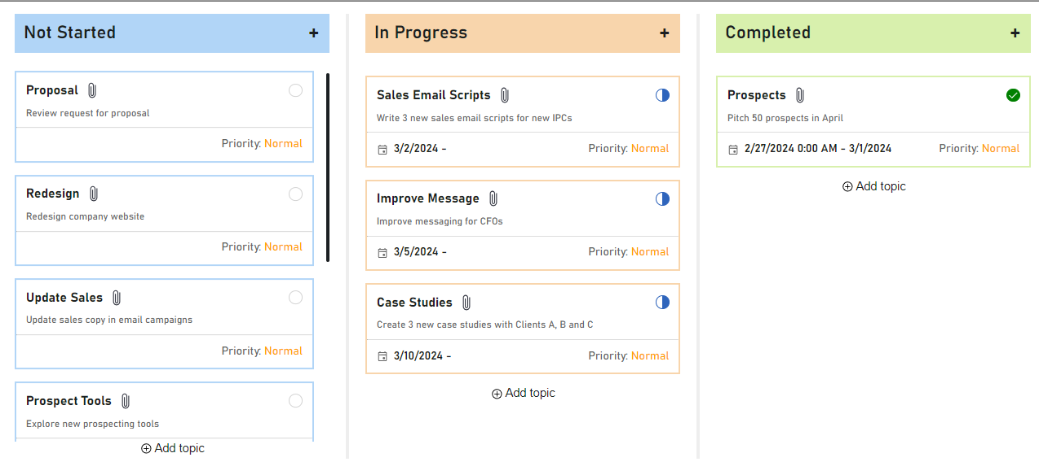Figure: Kanban Boards

**Importance:**

The importance of Kanban Boards in software project management:

1. **Visual Workflow:** Kanban boards provide a visual representation of work tasks and their progress.
2. **Limit Work-in-Progress (WIP):** By setting WIP limits, teams focus on completing tasks rather than multitasking.
3. **Efficiency Maximization:** Kanban helps optimize workflows, exposing bottlenecks and enhancing efficiency.
4. **[Transparency and Collaboration:](https://thedigitalprojectmanager.com/projects/pm-methodology/what-is-kanban/" \t "https://copilot.microsoft.com/_blank)** [These boards enhance transparency, foster collaboration, and promote data-based decision-making within teams](https://thedigitalprojectmanager.com/projects/pm-methodology/what-is-kanban/" \t "https://copilot.microsoft.com/_blank)

**Conclusion:**

In conclusion, usingMatchWare software tools which help to design Kanban board that enhances workflow management and collaboration. Kanban boards provide a structured way to track tasks, prioritize work, and visualize progress of my projects. By breaking down work into columns and using cards to represent individual tasks, teams can optimize efficiency, identify bottlenecks, and maintain a steady flow of work.

**Risk Matrix**

**Definition:**

The risk matrix is a tool that will provide information about the probability of a risk happening and if it’ll be a major or a minor problem. It is a widely used [project management technique](https://timeular.com/blog/project-management-techniques-and-tools/" \t "https://timeular.com/blog/risk-matrix/_blank) for risk analysis. The risk matrix is a standard tool in a project risk management plan and allows the project manager and team members to analyze every risk by determining each event as high, medium, or low impact.

**Tools:**

Wondershare Edrawmax and Asana

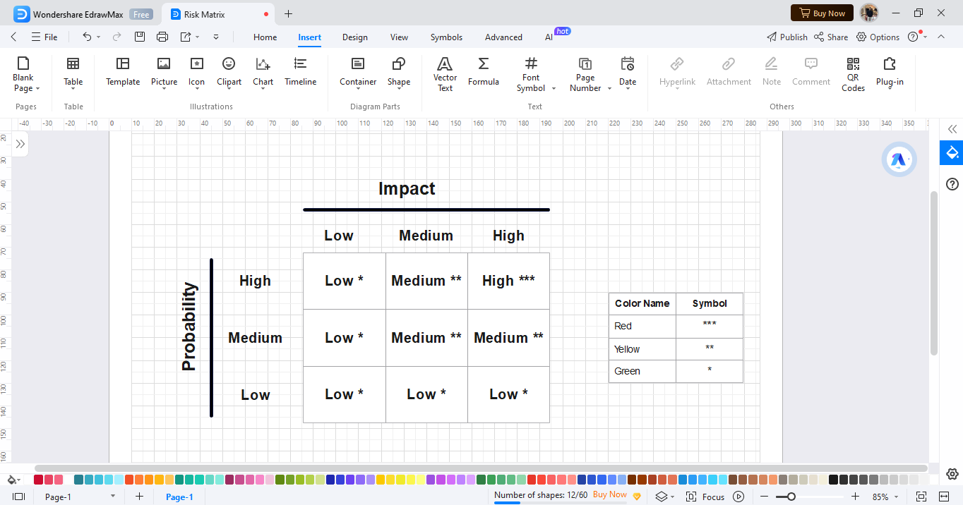

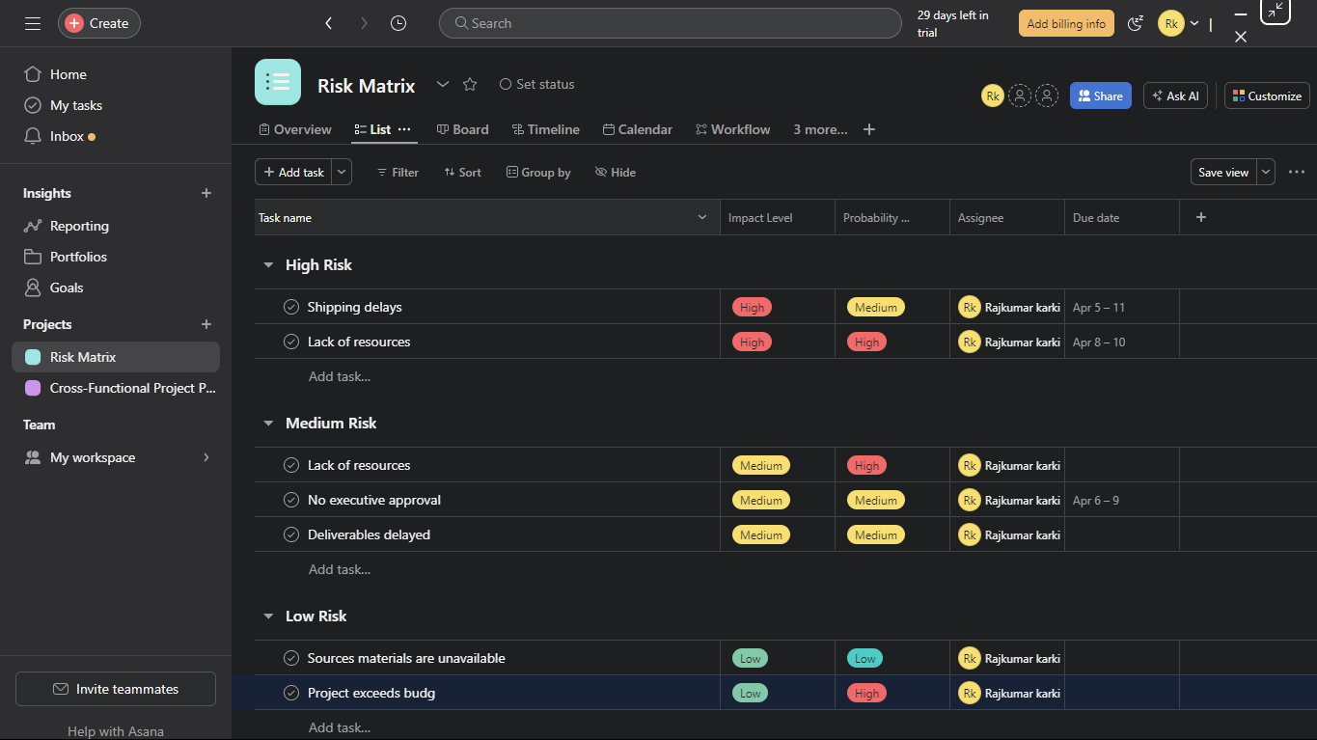

Figure: Risk Matrix

**Importance:**

The importance of Risk Matrix in software project management:

1. **Proactive Risk Identification:** A risk matrix helps identify potential risks early, allowing proactive mitigation.
2. **Resource Allocation:** It enables effective resource allocation to address critical risks.
3. **Prioritization:** Project managers can prioritize actions based on risk severity.
4. **Stakeholder Communication:** The risk matrix facilitates risk communication with stakeholders.
5. **[Holistic View:](https://projectmanagementacademy.net/resources/blog/risk-matrix/" \t "https://copilot.microsoft.com/_blank)** [It provides a visual representation of project risks](https://projectmanagementacademy.net/resources/blog/risk-matrix/" \t "https://copilot.microsoft.com/_blank)

**Conclusion:**

In conclusion, Edrawmax software tools help to design risk matrix and Asana software tools help to create Risk Matrix which provides a clear view of the threats surrounding an organization. It helps assess and categorize risks based on severity whether for-profit or non-profit. By visually representing risks and their potential impact, organizations can make informed decisions, allocate resources effectively, and implement appropriate risk mitigation strategies.

**Time Sheets**

**Definition:**

A timesheet is a time-tracking tool that helps employers keep an eye on labor costs. Timesheets are used by management, human resources and accounting departments to record time and pay employees based on the calculation of their total work hours. The most common association is with time cards or time clocks.

**Tools:**

MatchWare MindView 9

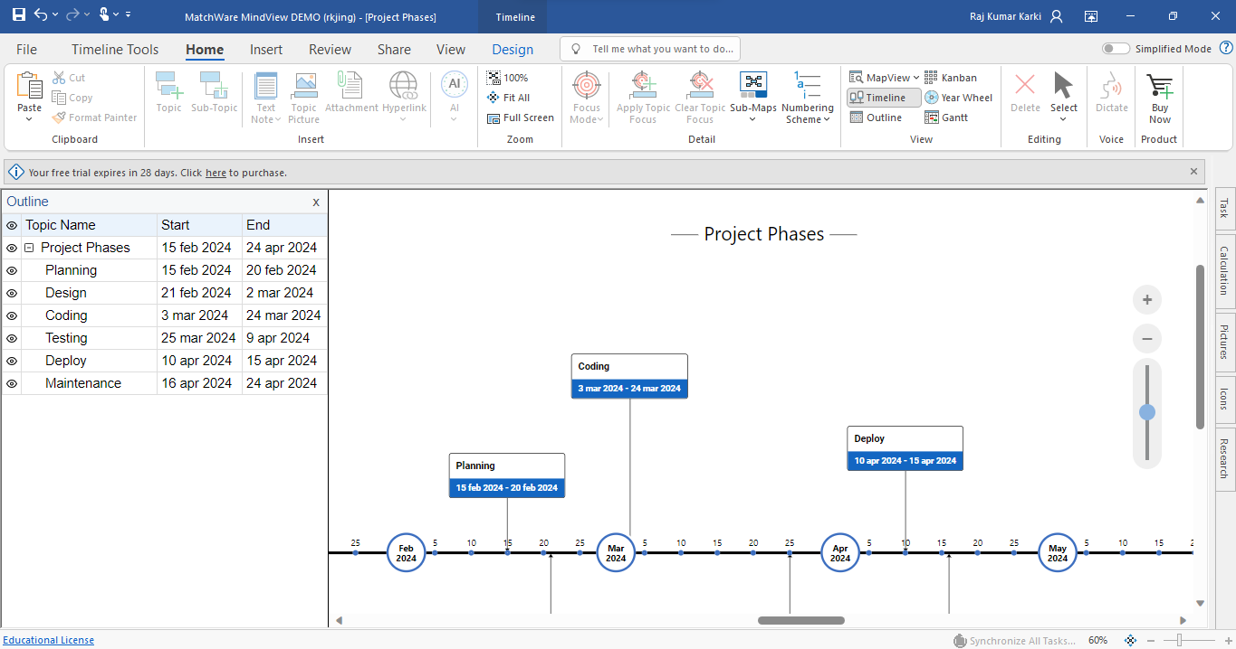

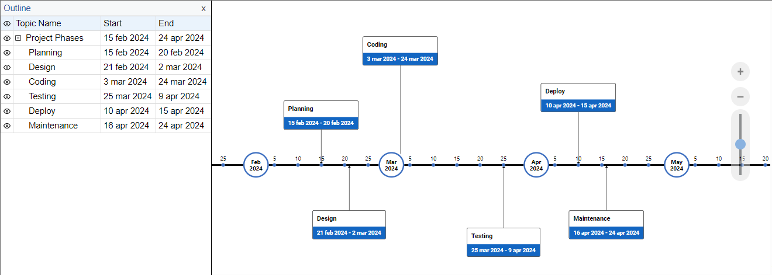

Figure: Time sheets

**Importance:**

The importance of Time Sheets in software project management:

1. **Resource Utilization Monitoring:**

* Time sheets help project managers monitor resource utilization.
* [They track how much time team members spend on specific tasks, allowing efficient allocation of resources](https://www.knowledgehut.com/blog/project-management/timesheet-project-management" \t "https://copilot.microsoft.com/_blank).

1. **Identifying Bottlenecks and Inefficiencies:**

* Time sheets enable the identification of potential bottlenecks or inefficiencies.
* [Project managers can take appropriate actions to optimize project timelines and resource allocation](https://www.knowledgehut.com/blog/project-management/timesheet-project-management" \t "https://copilot.microsoft.com/_blank).

1. **Work Completion Records:**

* Time sheets record work completed by team members.
* [This information is useful for client billing, payroll processing, and maintaining project documentation](https://www.knowledgehut.com/blog/project-management/timesheet-project-management).

1. **Real-Time Insights and Decision-Making:**

* Modern time sheet software provides real-time insights into task progress and resource allocation.
* [Managers can make informed decisions to keep the project on schedule](https://www.knowledgehut.com/blog/project-management/timesheet-project-management).

1. **Efficiency Boost and Compliance:**

* Time sheets help boost employee productivity.
* [They streamline project management, increase billing accuracy, monitor attendance, and ensure compliance with labor laws](https://day.io/blog/benefits-of-timesheets-for-your-business/" \t "https://copilot.microsoft.com/_blank).

**Conclusion:**

In Conclusion, using MatchWare software tools which help to create Time sheets which shows tracking work hours, project progress, and resource allocation, recording time spent on tasks, employees, or projects and performance evaluation.

**Project Dashboards**

**Definition:**

A project dashboard is a [project management](https://www.indeed.com/career-advice/career-development/project-management-basics" \t "https://www.indeed.com/career-advice/career-development/_blank) tool businesses use to track key performance indicators for various projects. Dashboards can show performance metrics, display progress reports and highlight areas that require attention. They can help monitor the success of specific campaigns, processes and projects.

**Tools:**

Businessmap

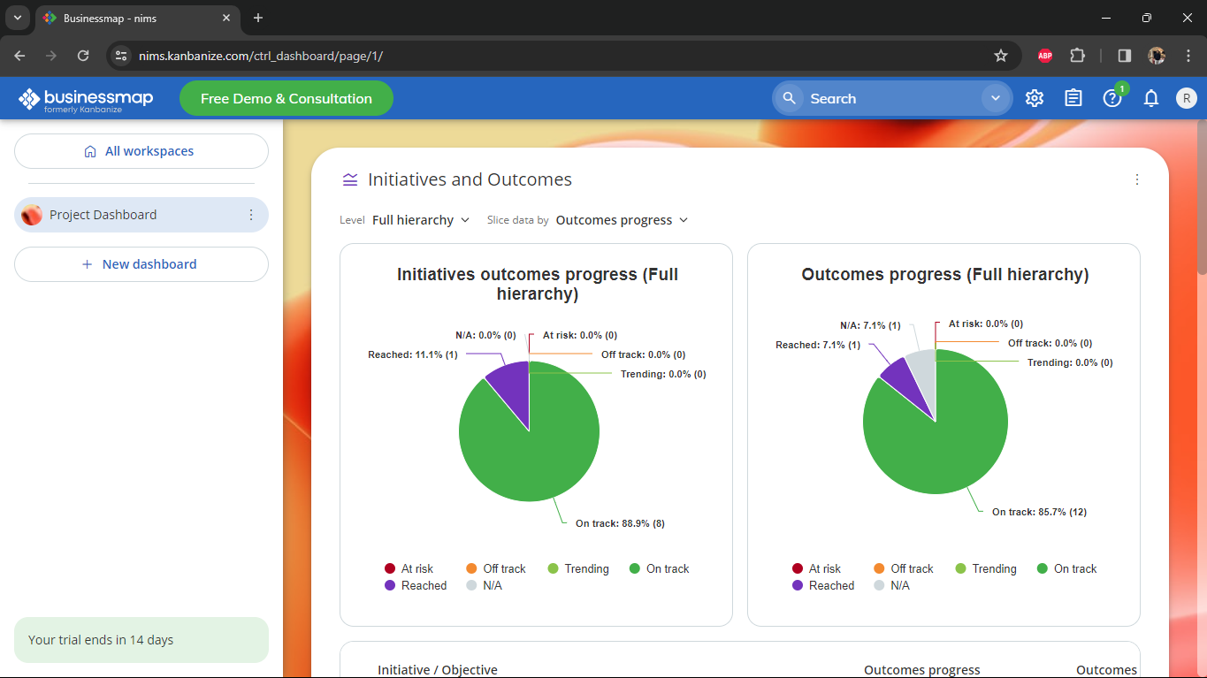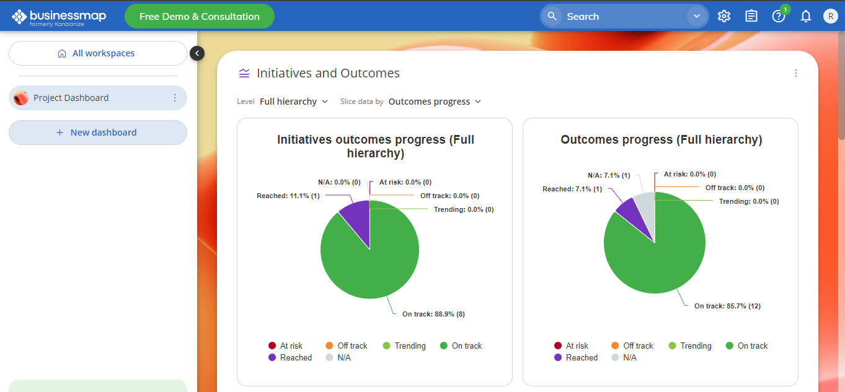

Figure: Project Dashboard

**Importance:**

For organizations that use projects to drive strategy execution, the project dashboard serves several important functions:

* **It directly links individual projects to strategic goals.**
* **It serves as an organization-wide strategy communication tool.**
* **It allows for fast identification of projects or milestones that are falling behind.**
* **It simplifies performance reporting.**

**Conclusion:**

**In Conclusion,** Businessmap software tools help to create a project dashboard [which provides project managers with a comprehensive view of project progress, facilitates data-driven decision-making, and enhances communication and collaboration among team members](https://teamhub.com/blog/creating-a-simplified-project-dashboard-for-easier-project-management/" \t "https://edgeservices.bing.com/edgesvc/_blank).

**Critical Path Method (CPM)**

**Definition:**

The critical path method (CPM) is a step-by-step [project management](https://www.techtarget.com/searchcio/definition/project-management) technique for process planning that defines critical and non-critical tasks with the goal of preventing project schedule problems and process [bottlenecks](https://www.techtarget.com/searchnetworking/definition/bottleneck). CPM is ideally suited to projects consisting of numerous activities that interact in a complex manner.

**Tools:**

Wondershare Edrawmax

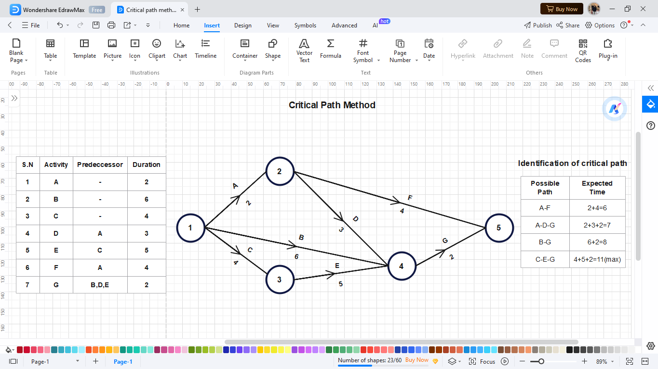

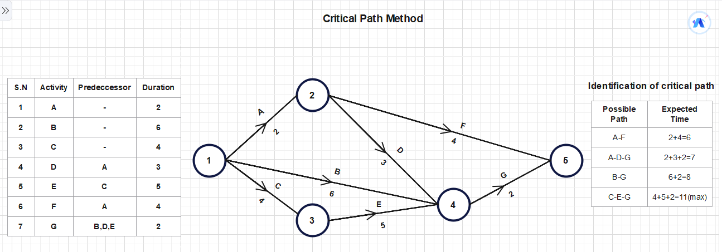

Figure: Critical Path Method

**Importance:**

The importance of the Critical Path Method (CPM) in software project management:

* CPM allows project managers to visually represent the project schedule.
* By identifying the critical path, project teams can understand the sequence of tasks and their inter-dependencies.
* CPM helps highlight critical tasks within the project.
* These critical tasks must be completed on time to avoid delays in the overall project timeline.
* By analyzing the critical path, project managers can identify potential risks.
* Understanding which tasks impact project completion allows for better risk management.
* CPM facilitates better communication among project team members.
* It ensures that everyone understands the critical tasks and their significance.

**Conclusion:**

In conclusion, Edrawmax software help to create the Critical Path Method (CPM) which helps plan and schedule complex projects by identifying the critical path with the sequence of activities that determines the minimum completion time. By analyzing dependencies and activity durations, project managers gain insights into project timelines and potential bottlenecks.

**Earned Value Management (EVM)**

**Definition:**

Earned Value Management (EVM) is a project performance management methodology that integrates cost, schedule, technical scope, and risk to assess progress against a baseline. EVM practitioners use the information generated by an Earned Value Management System (EVM) to identify problems, and forecast cost and schedule at completion.

**Tools:**

Xlxs

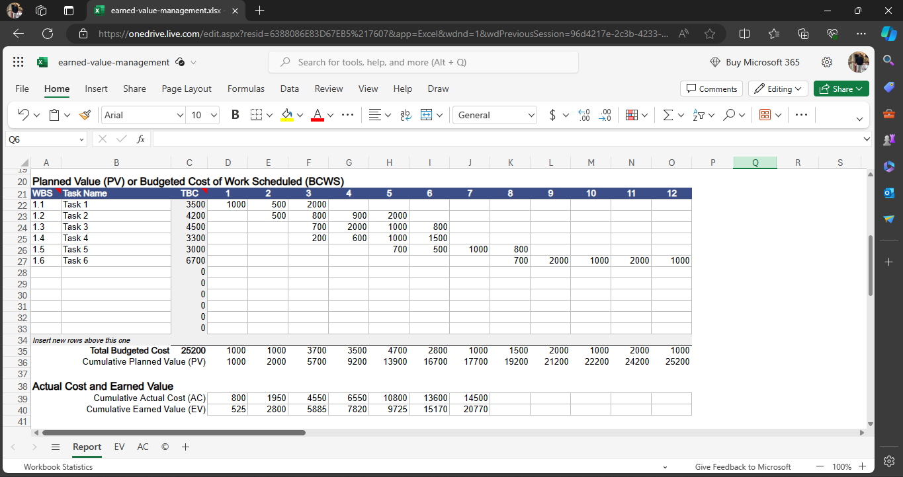

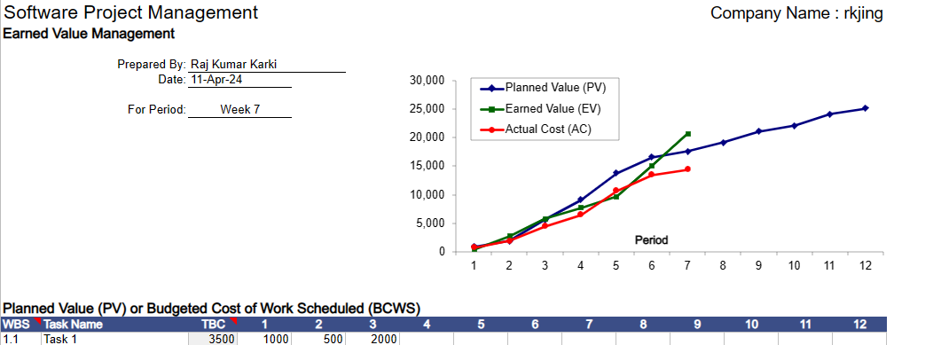

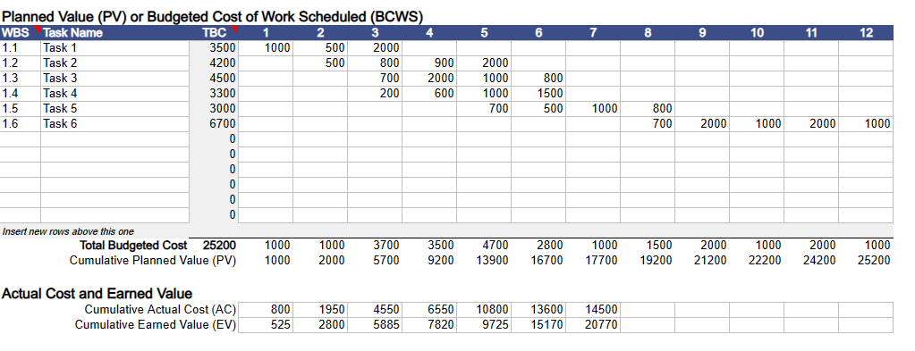

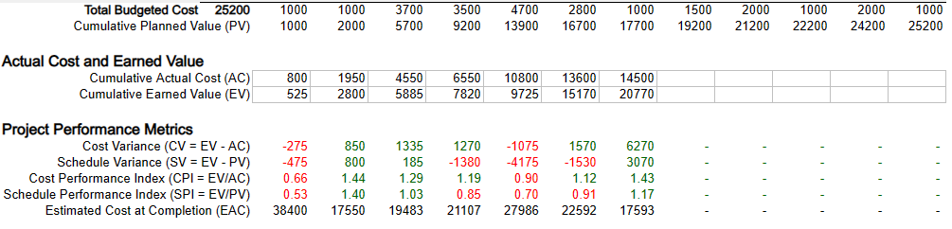

**Importance:**

The importance of Earned Value Management (EVM) in software project management:

1. **Project Performance Assessment:**

* EVM assesses project performance by evaluating measurements related to scope, schedule, and resources.
* [It provides an objective view of a project’s health, allowing project managers to track progress effectively](https://thedigitalprojectmanager.com/projects/pm-methodology/earned-value-management/" \t "https://copilot.microsoft.com/_blank).

1. **Early Visibility into Cost and Time Issues:**

* EVM offers early visibility into cost and time-related problems.
* [Managers can identify discrepancies and take proactive actions to address them](https://apmg-international.com/article/what-earned-value-management-and-why-it-important" \t "https://copilot.microsoft.com/_blank).

1. **Apples-to-Apples Reporting:**

* EVM allows reporting on both schedule and cost using a dollar value as the base unit.
* [It ensures an apples-to-apples comparison across different aspects of the project](https://thedigitalprojectmanager.com/projects/pm-methodology/earned-value-management/" \t "https://copilot.microsoft.com/_blank).

1. **Value-Based Approach:**

* Instead of relying solely on percentages of time and money spent, EVM focuses on the value created.
* [It considers the context of time and budget investments, providing a more accurate picture of project progress](https://thedigitalprojectmanager.com/projects/pm-methodology/earned-value-management/" \t "https://copilot.microsoft.com/_blank).

1. **Key EVM Metrics:**

* Planned Value (PV): Represents the time-based project spend based on the project plan.
* Earned Value (EV): Reflects the approved budget for work actually completed.
* Actual Cost (AC): Represents the costs actually incurred for completed work.
* [Metrics like Schedule Variance (SV) and Cost Variance (CV) help assess project schedule and budget performance](https://thedigitalprojectmanager.com/projects/pm-methodology/earned-value-management/" \t "https://copilot.microsoft.com/_blank).

**Conclusion:**

In Conclusion, using Xlxs Software tools help to generate Earned Value Management (EVM) in project management which provides a consistent, structured approach to project performance analysis. By integrating cost, schedule, and performance metrics, EVM offers insights into project health and progress. This allow project managers to assess cost and schedule performance, forecast outcomes, and make informed decisions.

**Project Pipeline Management**

**Definition:**

A Project Pipeline Management is a tool in project management that allows project managers to track the status of all their ongoing projects in one window. It helps in creating and monitoring a cycle of multiple project ideas, their execution, development, review, approval, and completion all managed on one tool.

**Tools:**

SmartSheet

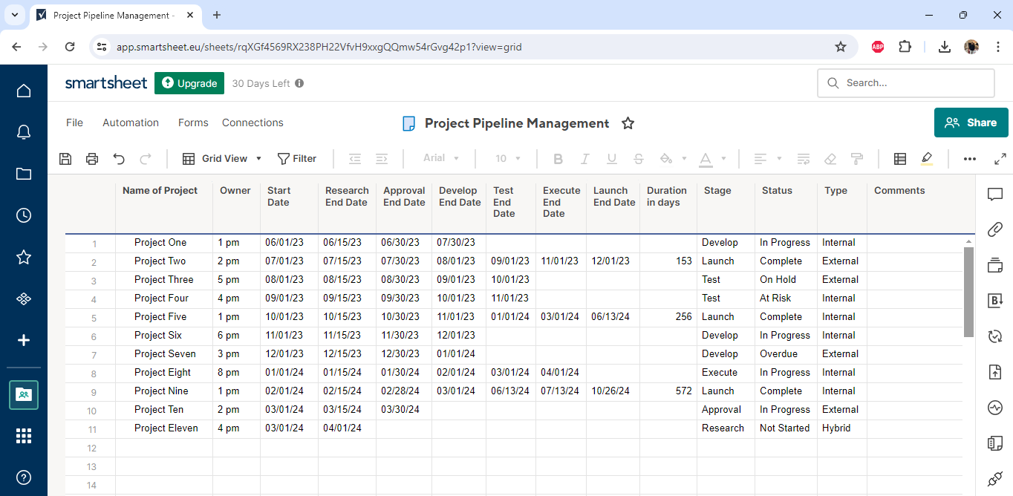

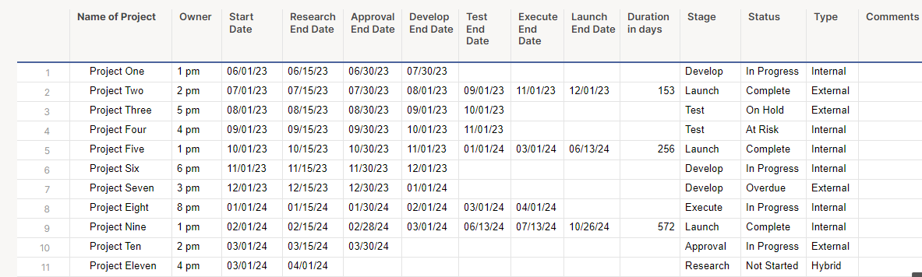

Figure: Project Pipeline Management

**Importance:**

 The importance of Project Pipeline Management in software project management:

1. **Strategic Project Selection:**

* A project pipeline helps project managers select the right projects from the beginning.
* It ensures that each individual project aligns with company goals and values.

1. Timely Communication:

* Critical actions are accurately communicated to teams and stakeholders.
* This ensures that everyone is on target and aware of project priorities.

1. **Risk Mitigation:**

* Precautions are taken in a timely manner to avoid failures.
* By managing the pipeline effectively, potential roadblocks and risks can be identified and addressed.

1. **Resource Allocation Optimization:**

* A well-managed project pipeline provides insights into timelines, progress, and statuses of multiple projects.

It helps allocate resources efficiently and ensures projects stay on track.

1. **Visibility and Roadblock Identification:**

* Project pipeline management reveals potential roadblocks and risks that may hinder project progress.
* [It allows project managers to take corrective actions promptly](https://creately.com/blog/project-management/project-pipeline-management/" \t "https://copilot.microsoft.com/_blank)

**Conclusion**

In Conclusion, using SmartSheet software tool help to create Project Pipeline Management which involves tracking multiple projects from ideation to launch, ensuring proper timelines, resource allocation, and mapped-out workflows. It also provides insights into project progress, potential roadblocks, and risks.